Week 13 Practical 13
Topics:
- Design reports from a database
  - Create database “ order”.
  - Create table ‘items_ordered’ using design view

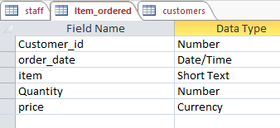

  - Create table customer using design view

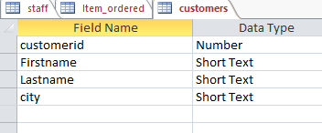

  - Insert following data to item_order table.

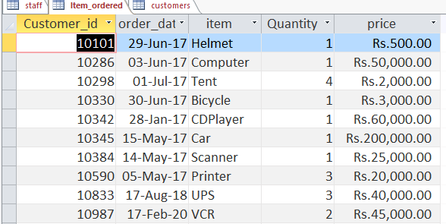

  - Insert following data to customer table

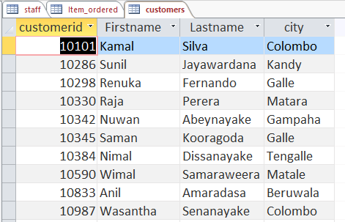

  - Create relationship between two tables
  - Create reports using ‘report’ option.
  - Create reports using report wizard.
  - Create report using report design view.

